**Practical No: 06**

**Aim:** 1) Introduction to Wikipedia

2) Create User account in Wikipedia

3) Contribute to Wikipedia

***1) Introduction to Wikipedia***

Wikipedia is a free, [multilingual](https://en.wikipedia.org/wiki/Multilingualism) [open-collaborative](https://en.wikipedia.org/wiki/Open_collaboration) [online encyclopedia](https://en.wikipedia.org/wiki/Online_encyclopedia) created and maintained by [a community of volunteer contributors](https://en.wikipedia.org/wiki/Wikipedians) using a [wiki](https://en.wikipedia.org/wiki/Wiki)-based editing system. Wikipedia is the largest general reference work on the [Internet](https://en.wikipedia.org/wiki/Internet),[[3]](https://en.wikipedia.org/wiki/Wikipedia#cite_note-Wiki20-5) and one of the 15 most popular websites as ranked by [Alexa](https://en.wikipedia.org/wiki/Alexa_Internet); in 2021, it was ranked as the 13th most-visited.[[4]](https://en.wikipedia.org/wiki/Wikipedia#cite_note-Alexa_siteinfo-6)[[note 3]](https://en.wikipedia.org/wiki/Wikipedia#cite_note-8) The project carries no [advertisements](https://en.wikipedia.org/wiki/Online_advertising) and is hosted by the [Wikimedia Foundation](https://en.wikipedia.org/wiki/Wikimedia_Foundation), an [American non-profit organization](https://en.wikipedia.org/wiki/501(c)(3)_organization) funded mainly through donations.

Wikipedia was launched on January 15, 2001, by [Jimmy Wales](https://en.wikipedia.org/wiki/Jimmy_Wales) and [Larry Sanger](https://en.wikipedia.org/wiki/Larry_Sanger); Sanger coined its name as a [portmanteau](https://en.wikipedia.org/wiki/Portmanteau) of "wiki" and "encyclopedia". Initially available only in English, versions in other languages were quickly developed. The [English Wikipedia](https://en.wikipedia.org/wiki/English_Wikipedia), with 6.3 million articles as of April 2021, is the largest of the [321 language editions](https://en.wikipedia.org/wiki/List_of_Wikipedias). Combined, Wikipedia's editions comprise more than 56 million articles, and attract more than 17 million edits and more than 1.7 billion unique visitors per month.

***2) Create User account in Wikipedia***

***Go to Wikipedia account creation link and enter details as shown in the picture:***

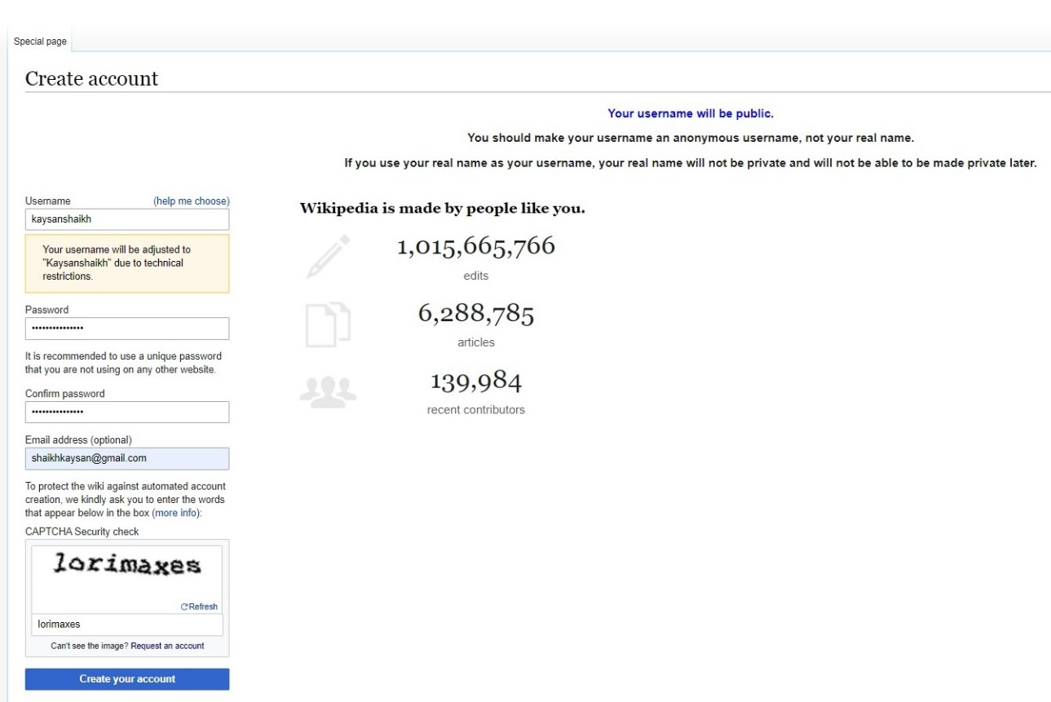

***This is how your account look after created.***

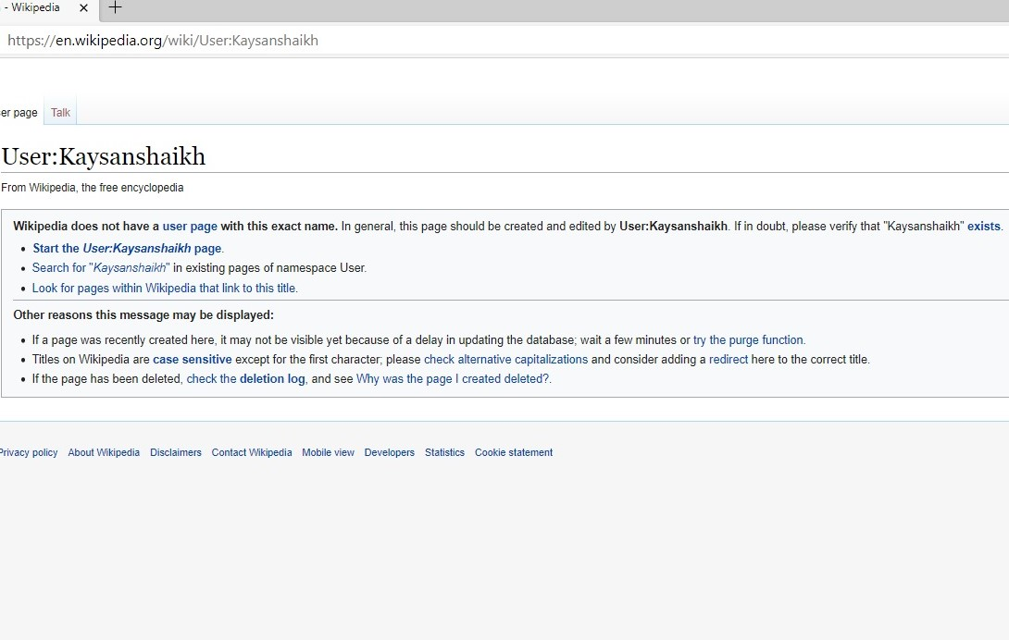

***3.Conribute to Wikipedia***

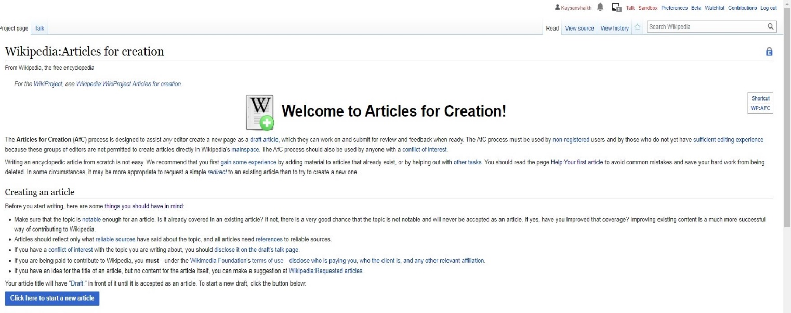**1st step: Go to ‘ask for it to be created’ link and you will be redirect to the page below, click on ‘click here to start a new article’.**

**2nd step:** **You will be redirected here and then choose the suitable option and complete all the required procedures as directed:**

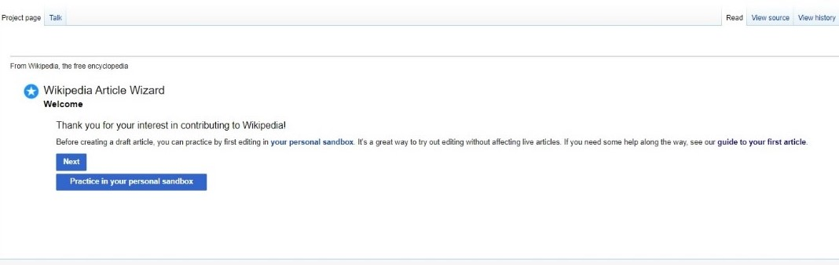

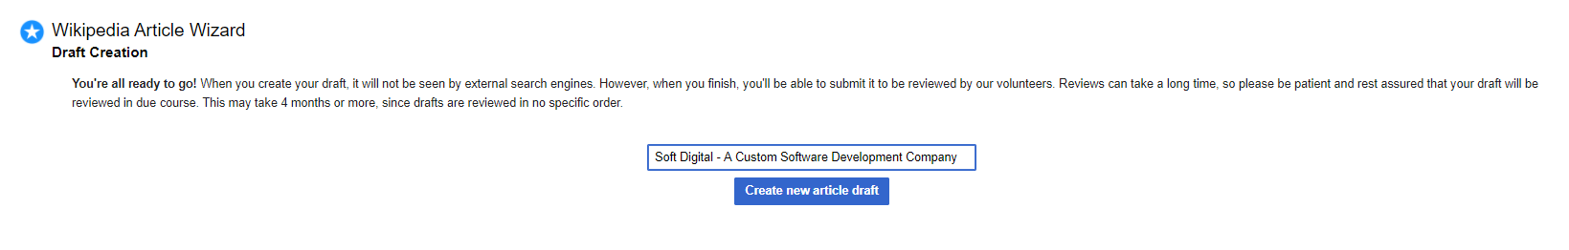**3rd Step: Enter the name of your Article to be drafted:**

**4th Step: Draft your Article Here and Publish it.**

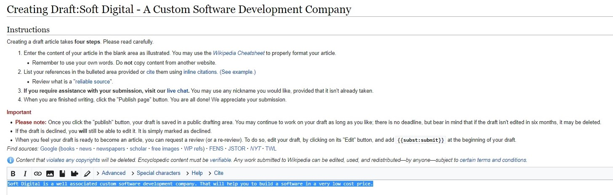

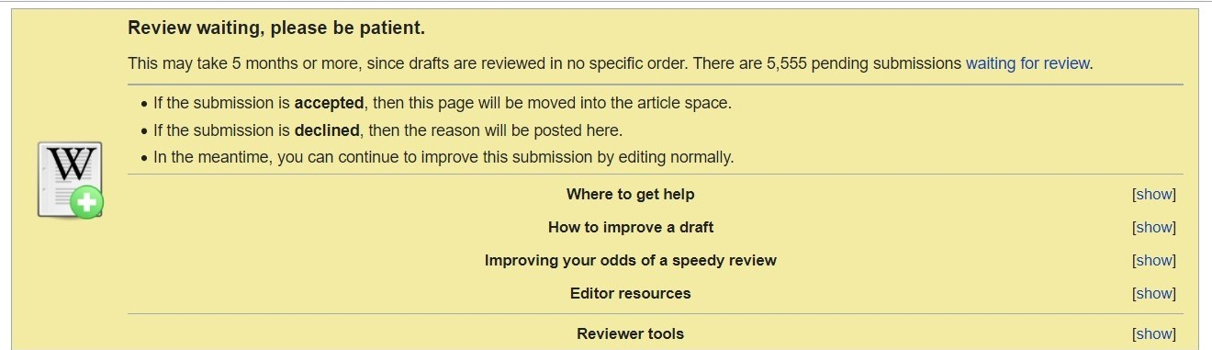**5th Step: You will be required to read the terms and conditions and your article will be drafted successfully.**